# Exercise Set#5 - The vi Linux Text Editor

**The Vi editor**

The Objective is to understand the vi editor to write a small C program

**Videos :** Linux5-vi_editor

**1. Vi Understanding**

**a. Open a “.c” file using the <vi > text editor command.**

**Ans :**

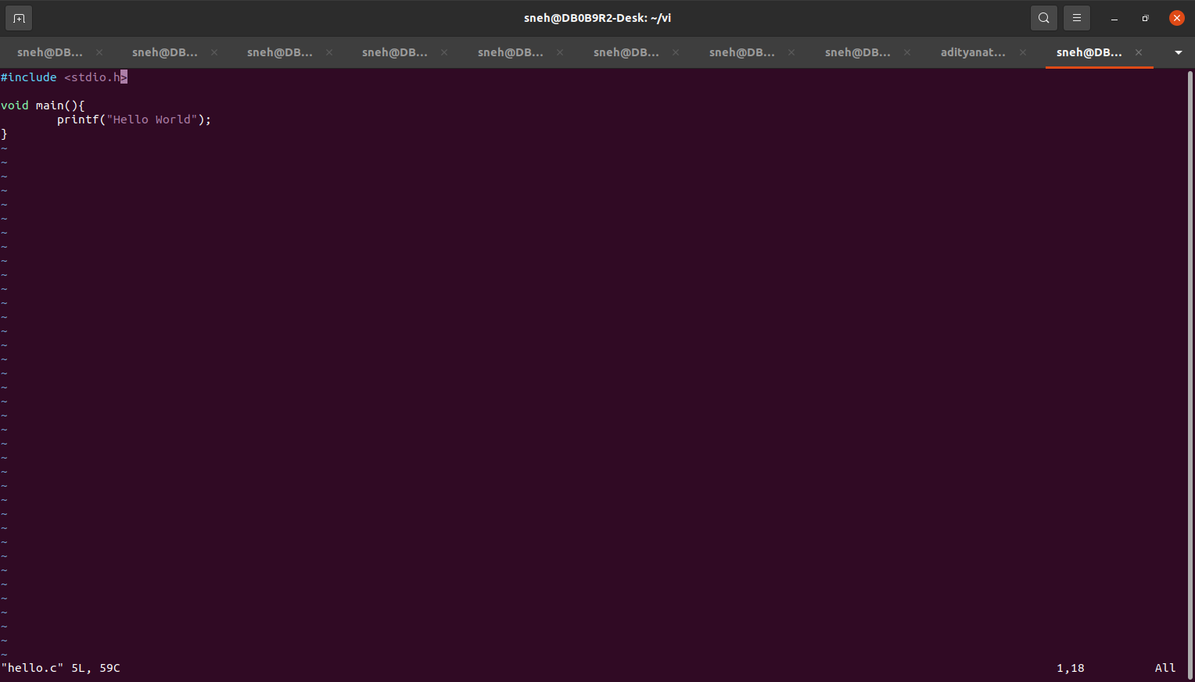

**b. Enter the “command mode” <esc>**

**Ans :**

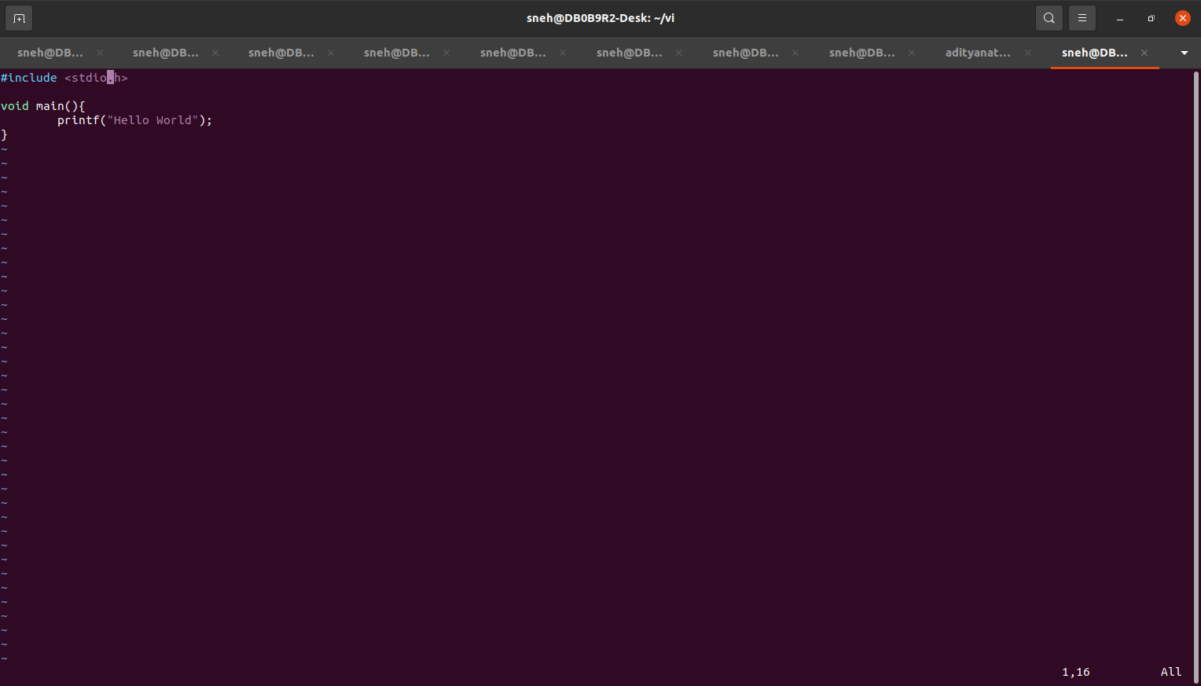

**c. Issue a command to enter the “edit mode” using <i>. Look for the various editing mode commands.**

**Ans :**



Insert Text: Press i to start inserting text at the cursor.

Append Text: Press a to append text after the cursor.

Insert at Beginning of Line: Press I to insert at the beginning of current line.

Insert at End of Line: Press A to insert at the end of the current line.

Open New Line Below: Press o to open a new line below the current line.

Open New Line Above: Press O to open a new line above the current line.

**d. Write a small “c” program to print “Hello World” and write few lines of code using “C” language.**

**Ans :**

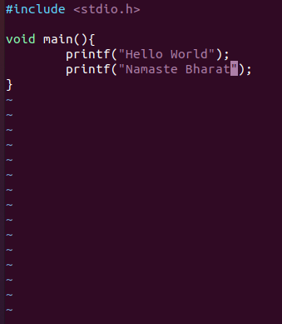

**e. Save the file without exiting.**

**Ans :**

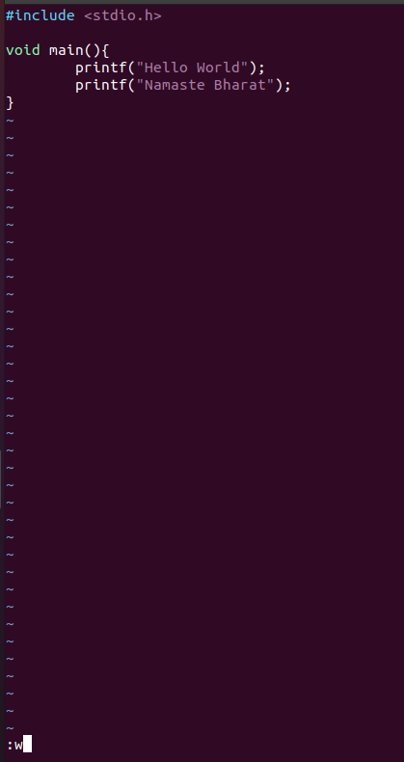

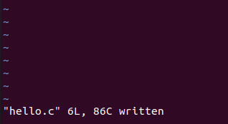

**f. Copy the “printf(“Hello World”);” line and paste it to another line.**

**Ans :**

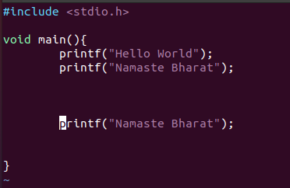

**g. Copy 5 lines at once and paste it at another location**

**Ans :**

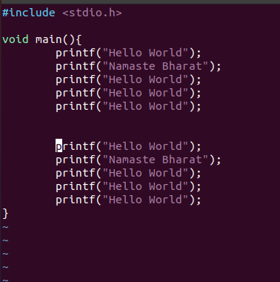

**h. Delete the 5 lines copied recently by single command**

**Ans :**

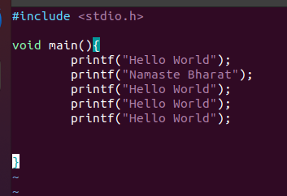

**i. Delete the 1st “printf(“Hello World”);”**

**Ans :**

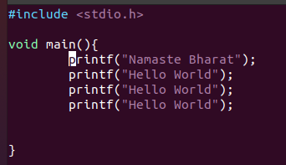

**j. Save the current file contents**

**Ans :**

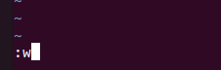



**k. Search the string “printf” in the file; find the next occurrence of the string.**

**Ans :**

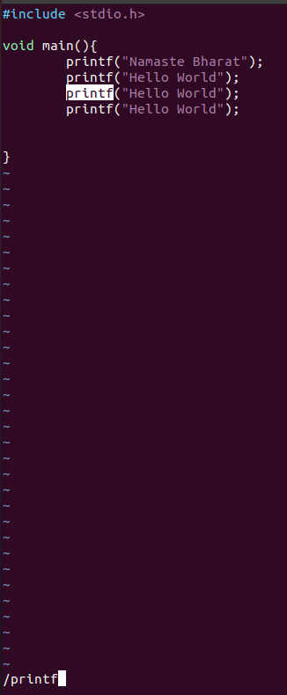

/printf will search for the string "printf" in the file. To find the next occurrence, press n. To search in the reverse direction, press N.

?printf will start from last occurrence.

Or else Just move cursor to printf and hit ‘*’ or ‘n’ button to find the next printf. ‘N’ to move to previous occurrence.

**l. Delete one occurrence of “printf” using the “delete current word command”. And insert “print” at its place.**

**Ans :**

Move the cursor to the occurrence of "printf" you want to change.

Press dw to delete the current printf.

Press i to enter insert mode.

Type "print".

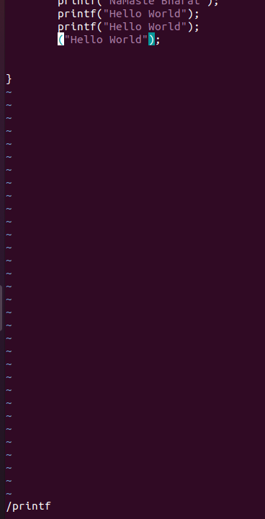

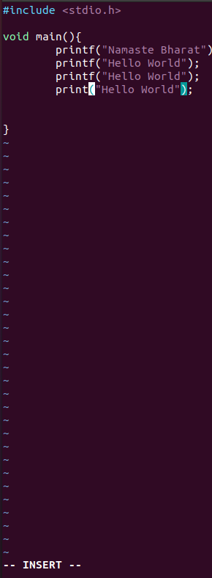

**m. Use the replace command to replace “print” by “printf”.**

**Ans :**

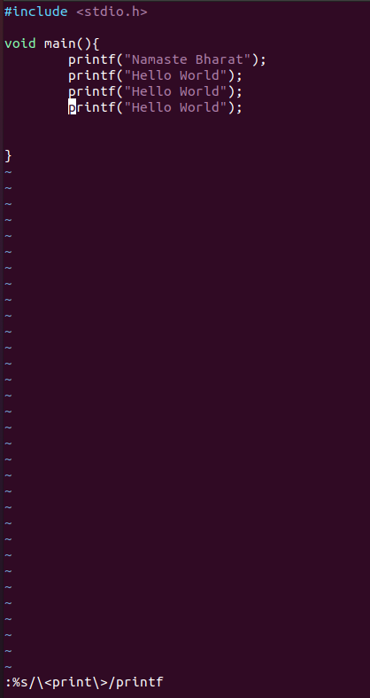

**n. Save the file and quit “vi”**

**Ans :**

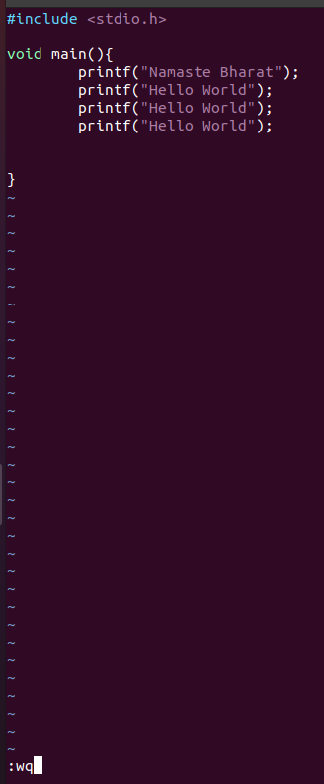

**o. Open multiple files in vi, copy 5 lines from one file to another file**

**Ans :**

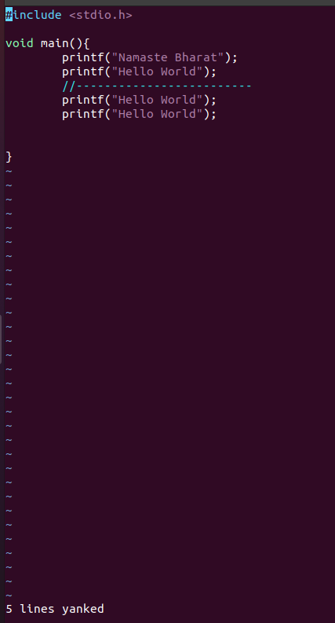

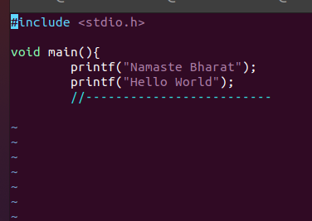

**p. Open same file in vi in multiple windows**

**Ans :**

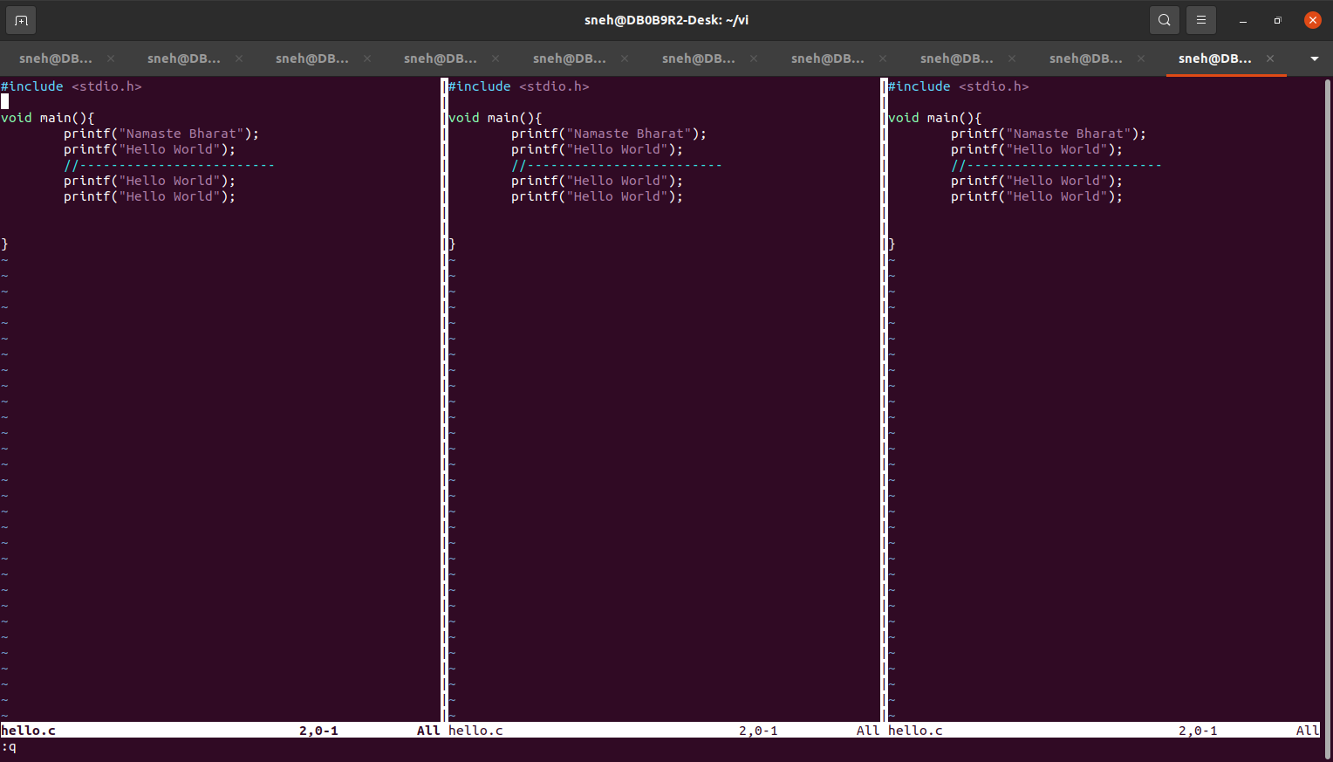

**q. Tag the source directory and trace function calls <ctags>**

**Ans :**

ctags (short for "C tags") is a tool used to generate an index (or "tag") file of source code definitions in a programming project. This index file can then be used by text editors or integrated development environments (IDEs) to quickly navigate and locate definitions of functions, variables, classes, and other code elements within the project.

ctags myfile.c - Generate tags for a single file.

ctags -R - Generate tags recursively for all files in a directory

Jump to the definition of a tag: Ctrl-]

Jump back from a tag: Ctrl-T

�